**Herguan University**

**Fall 2015**

**Course Name:** Project Schedule & Cost Control

**Course Number:** PJM 530

**Student Id:** 151111

**Student Name:** Vishal Kumar

**Instructor:** Prof. Wiselin Mathuram

**Date:** 12/04/2015

1. **Develop the project schedule showing dependencies**

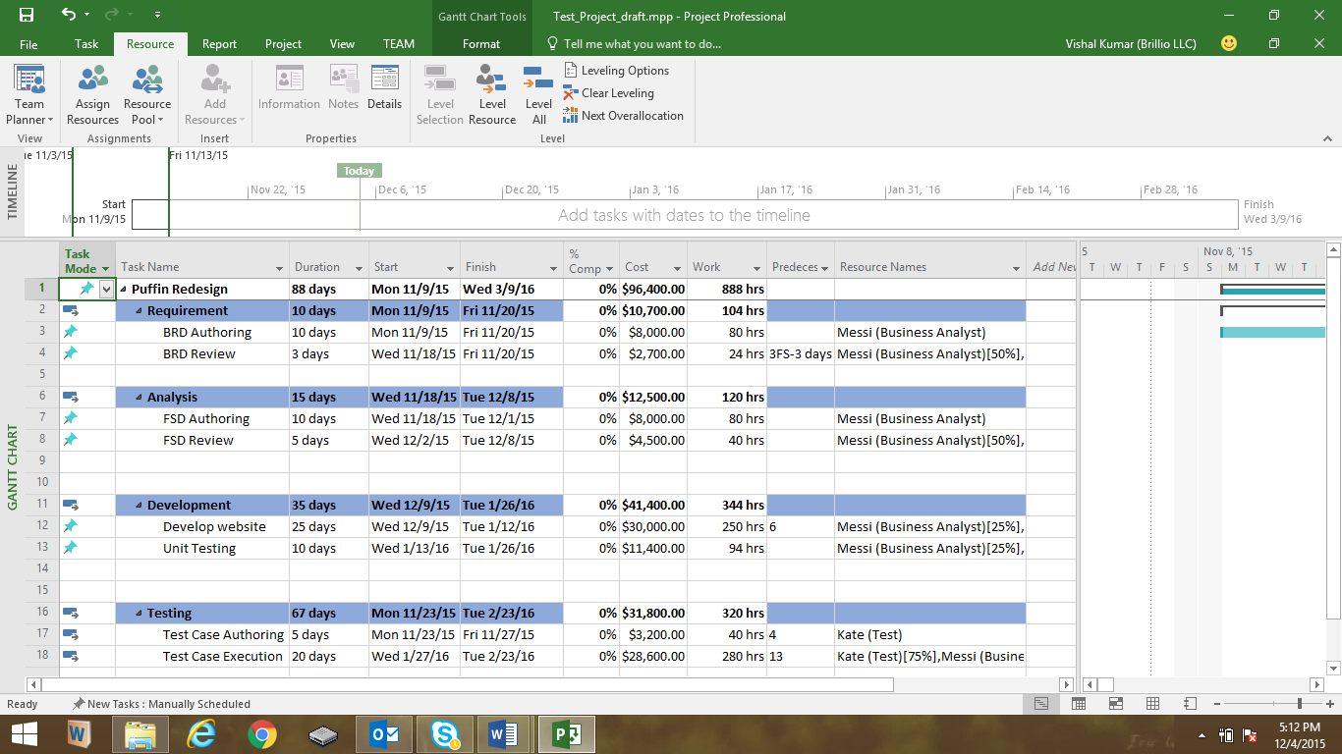

1. **Gantt Chart**

Below is Gantt Chart view: Go to Task-> Go to Gantt Chart and select Gantt Chart

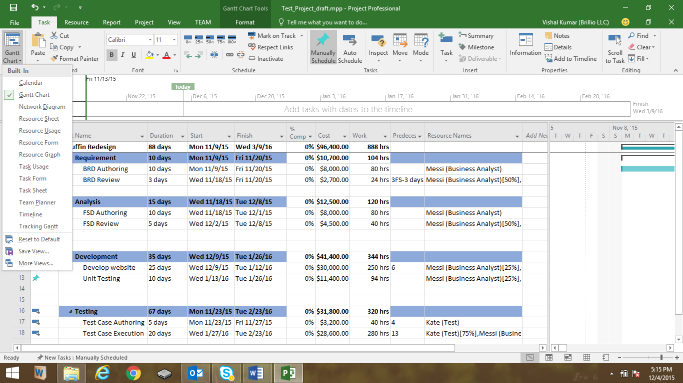

1. **Critical path**

For Critical Path, go to View-> From Filter drop down, select “Critical”

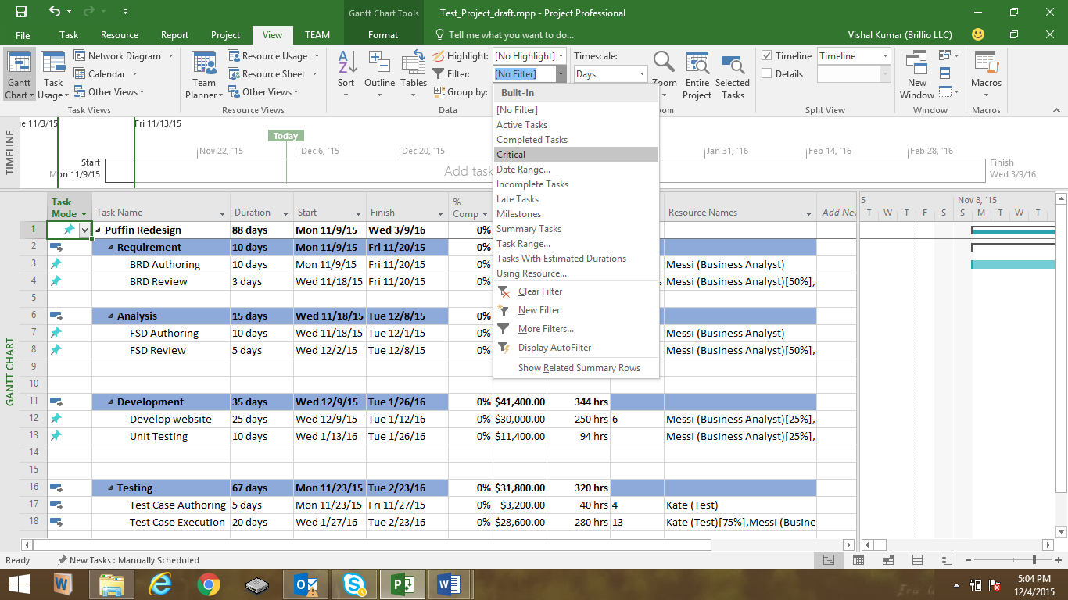

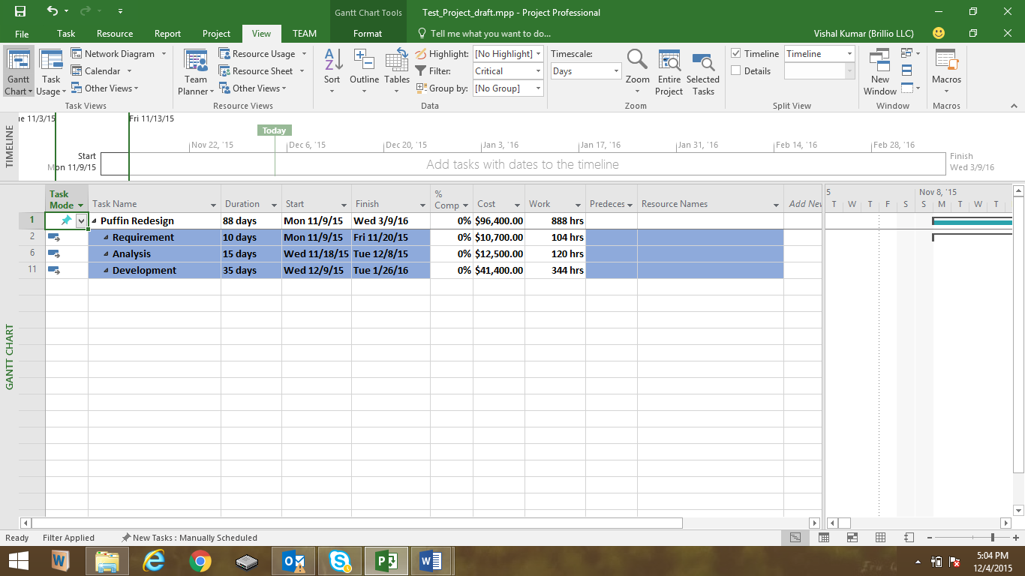

1. **Resource Leveling**

Here Messi is over allocated and we can level him by going to Resource-> Level All option:

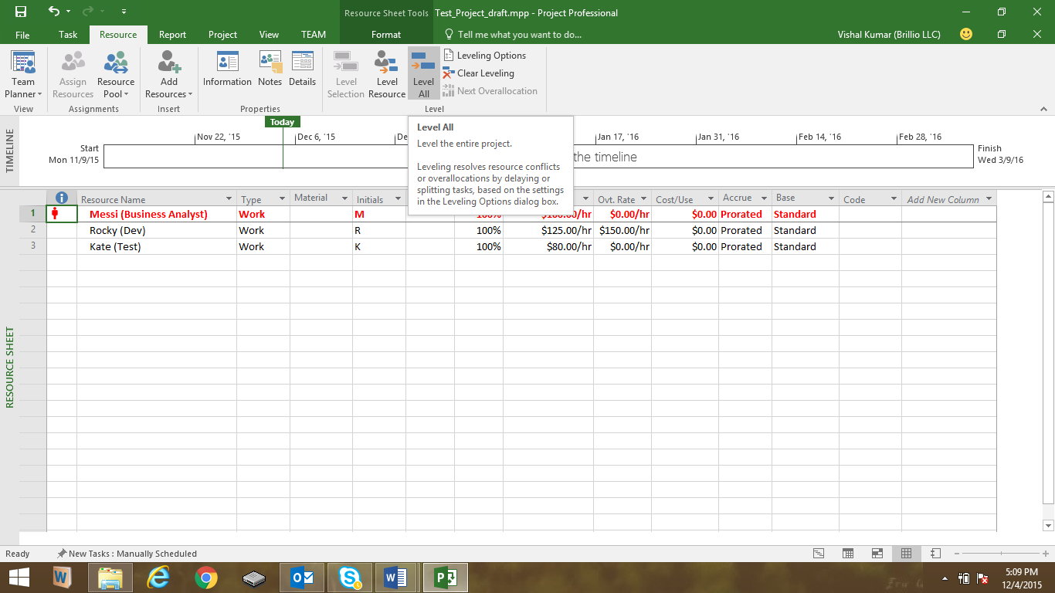

1. **Setting project baseline**

Go to Project-> Set Baseline

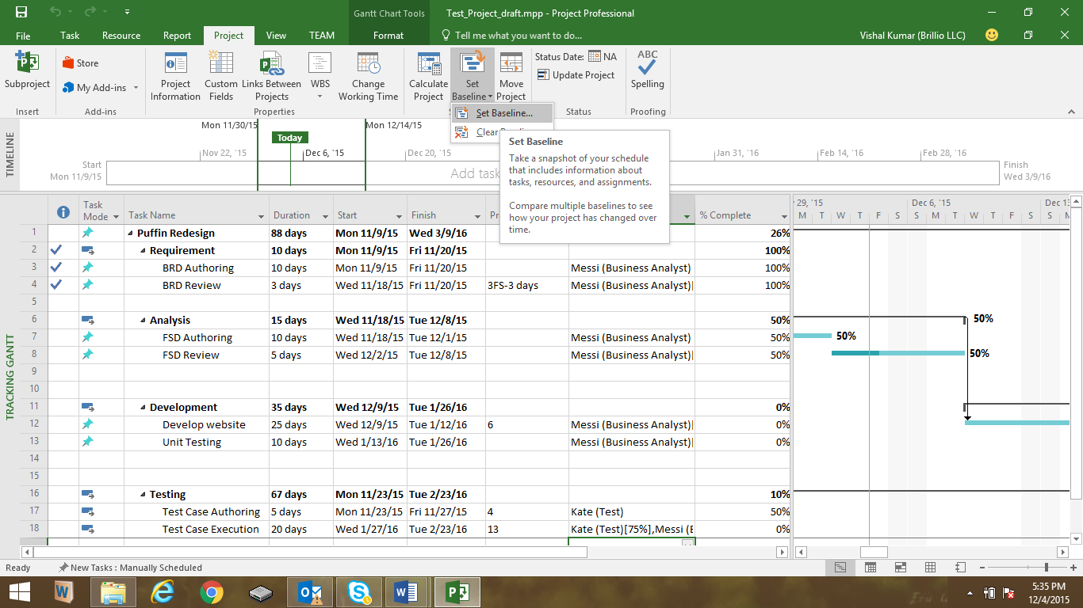

While clicking on it, Click “OK” in the box.

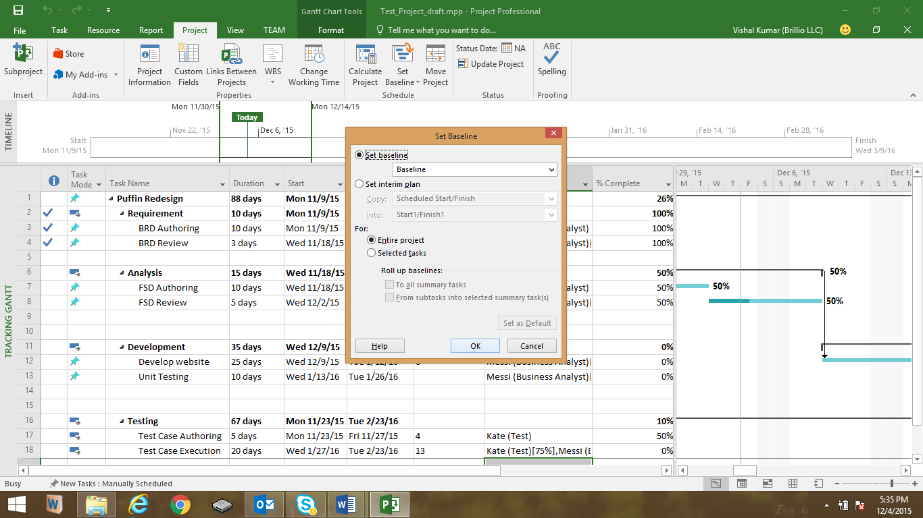

1. **Earned value cost indicators**

Go to View-> Tables-> Select More Tables-> select “Earned value cost indicator” from pop up box.

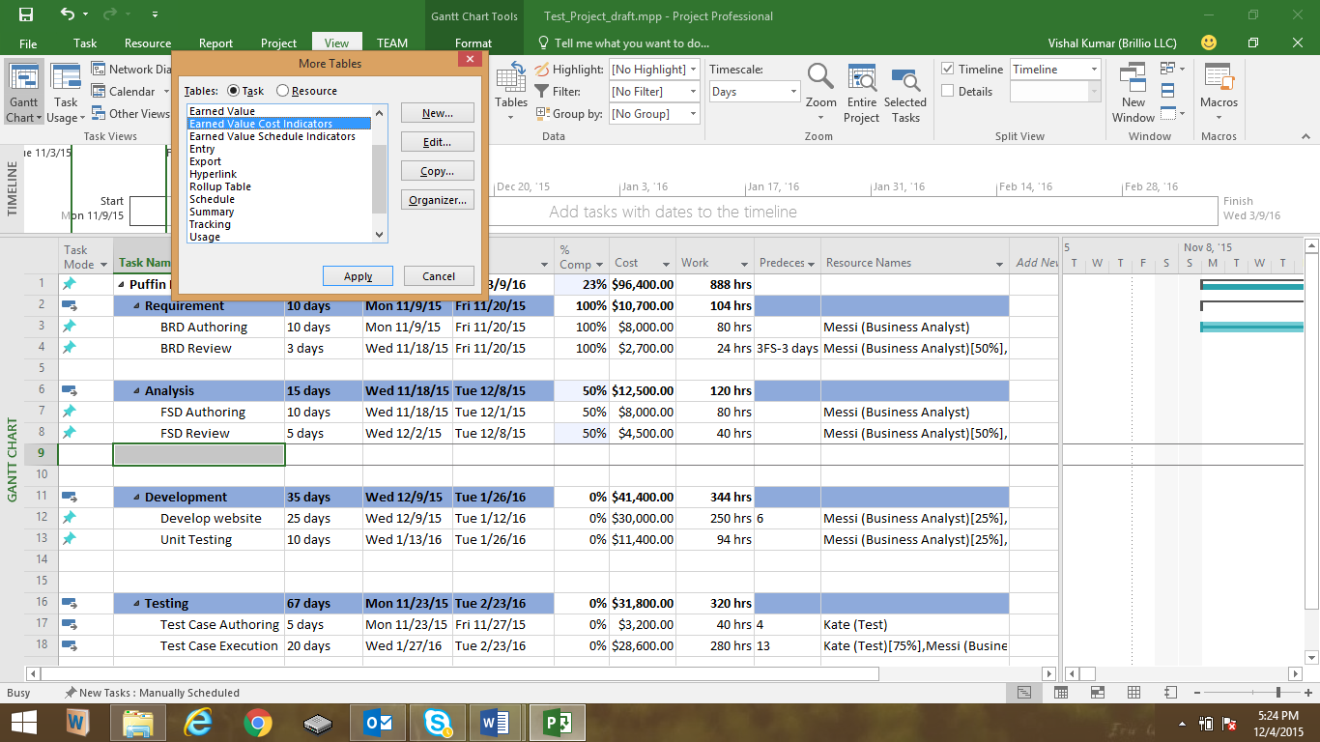

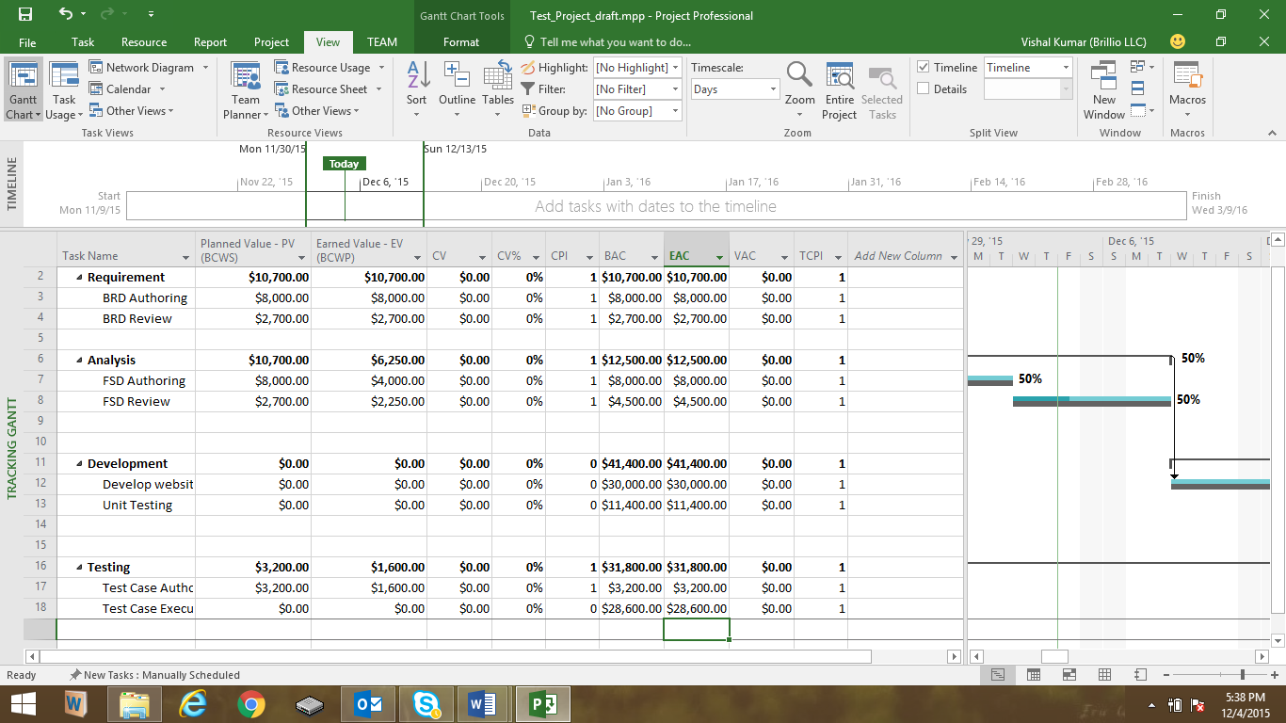

1. **Earned value schedule indicators**

Go to View-> Tables-> Select More Tables-> select Earned value schedule indicators from pop up box

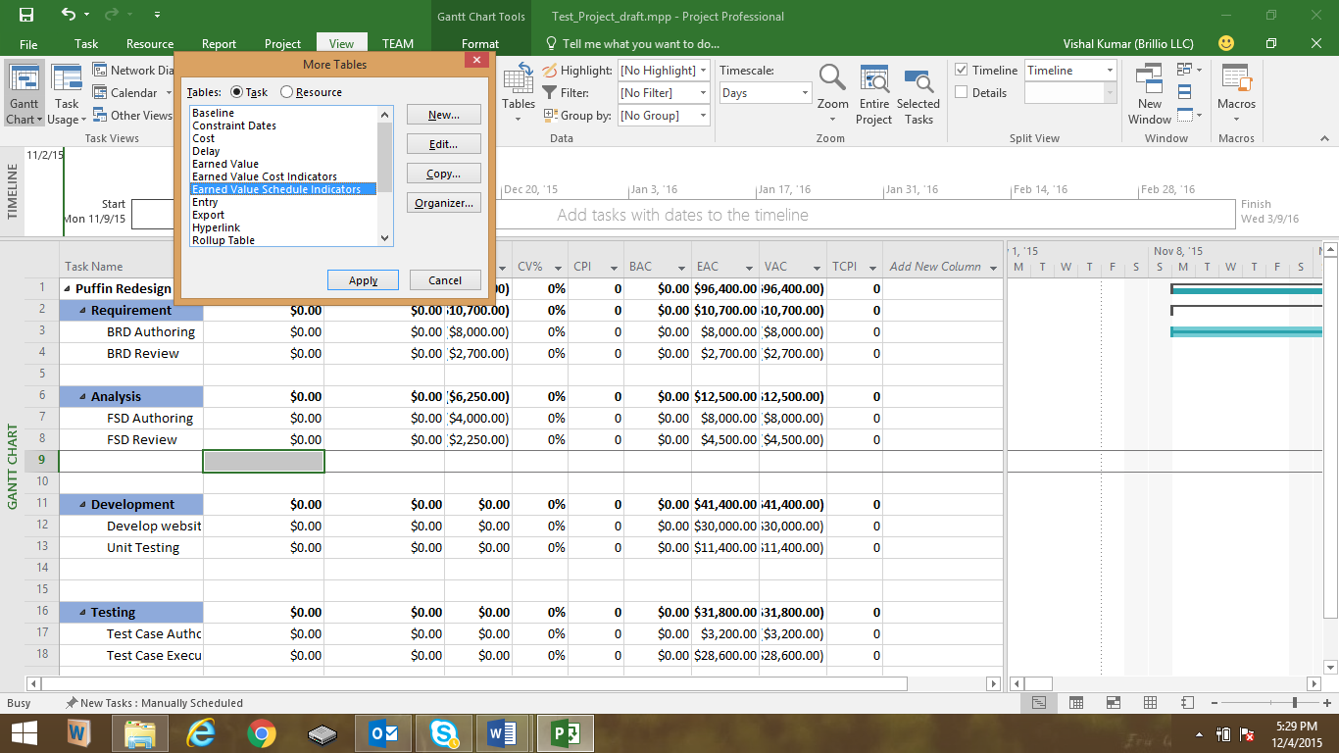

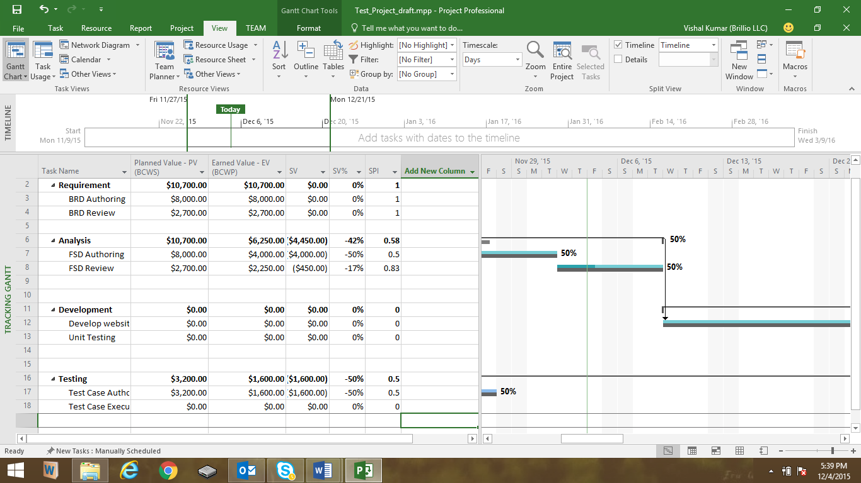

1. **Showing slack in the Gantt chart**

To show the total slack in Gantt Chart, click on Format-> Check Critical Task check box, Slack and click on Format-> Bar Style. You will get below dialog box open.

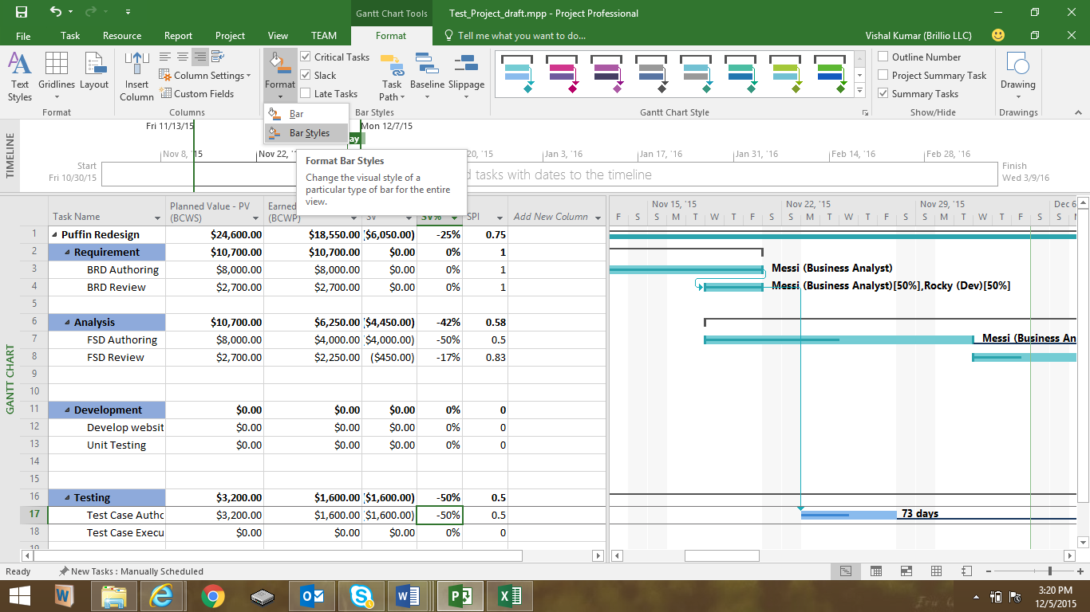

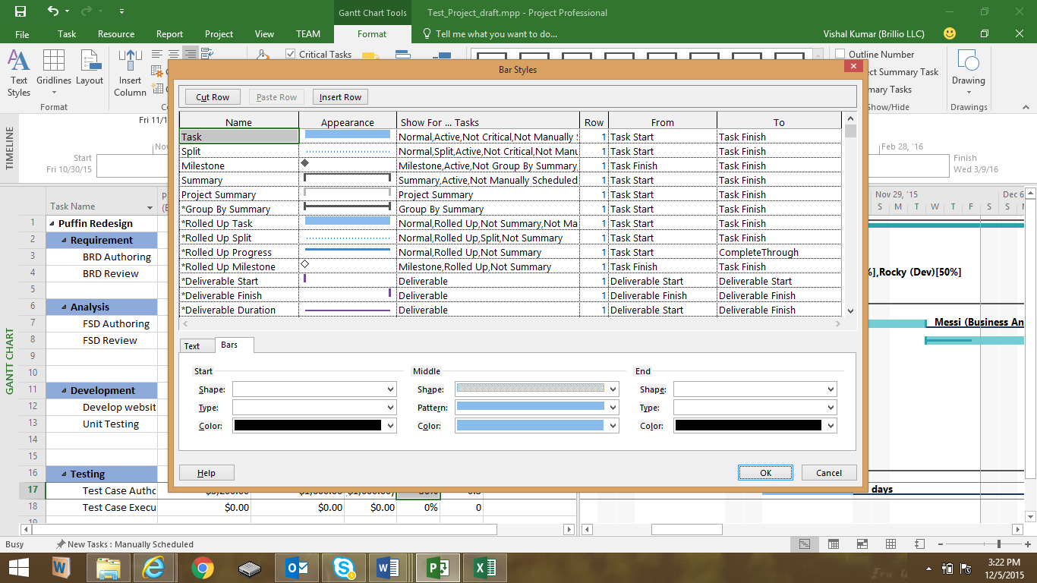

Now, Go to “Text” at left side of a dialog box-> click on “Right” and select “Total Slack” and click on “OK”

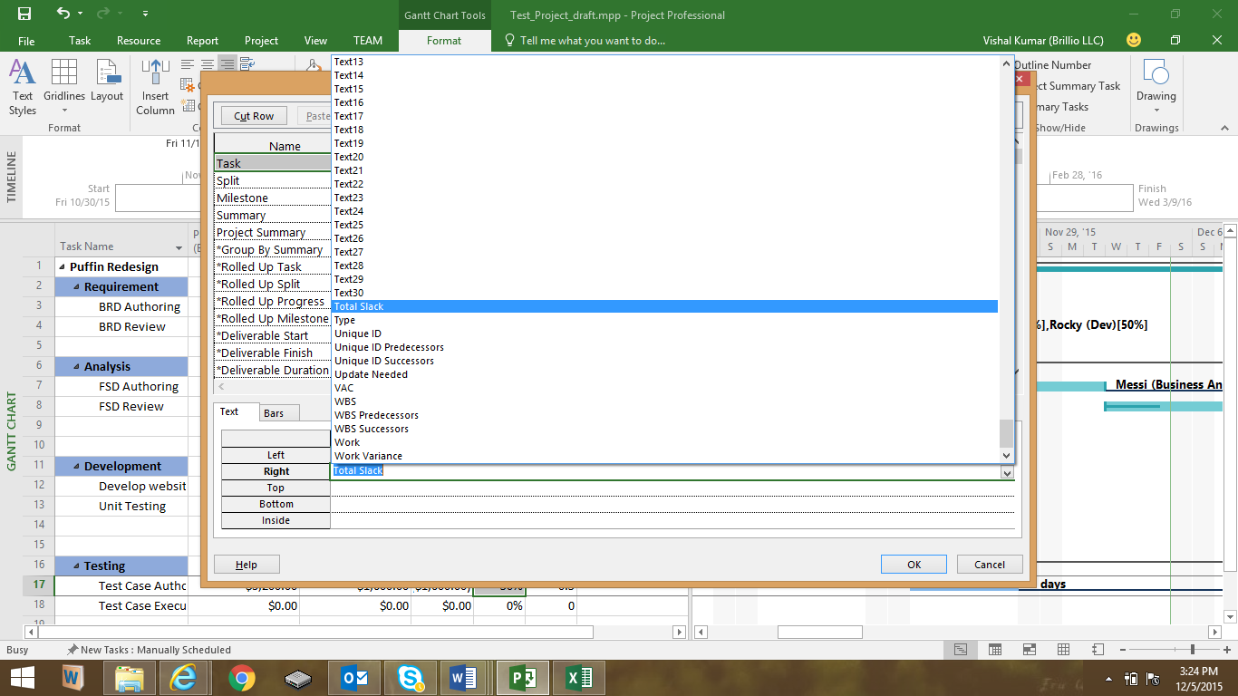

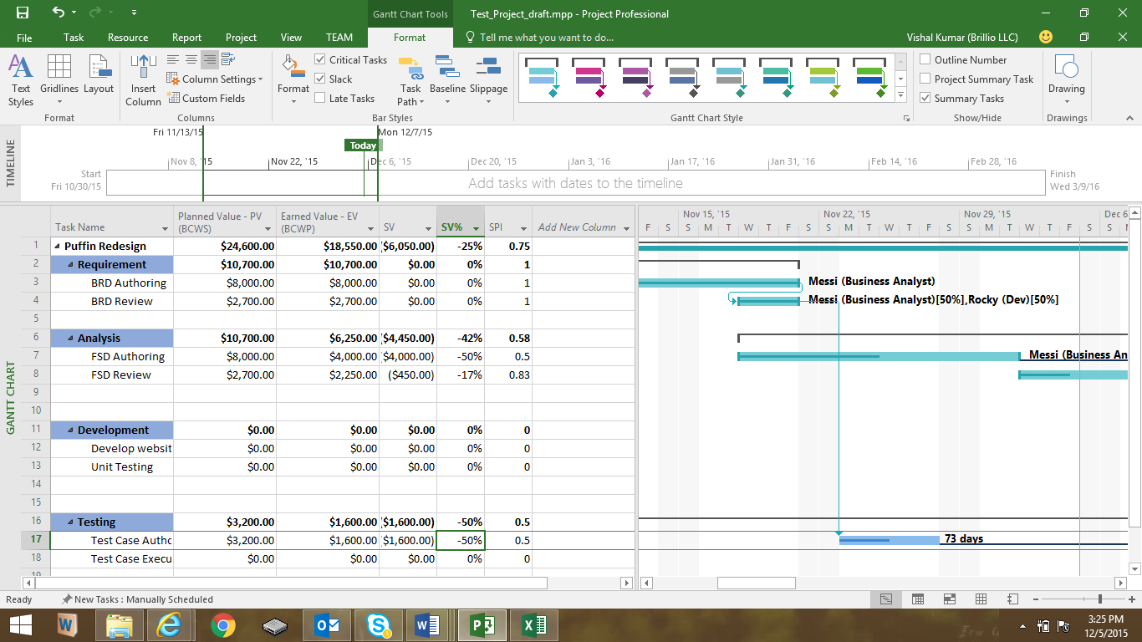

1. **Add a milestone**

To add a mile stone at any phase of development life cycle, simple double click on that phase. For example, I am adding a milestone for “Requirement Phase” of this project.

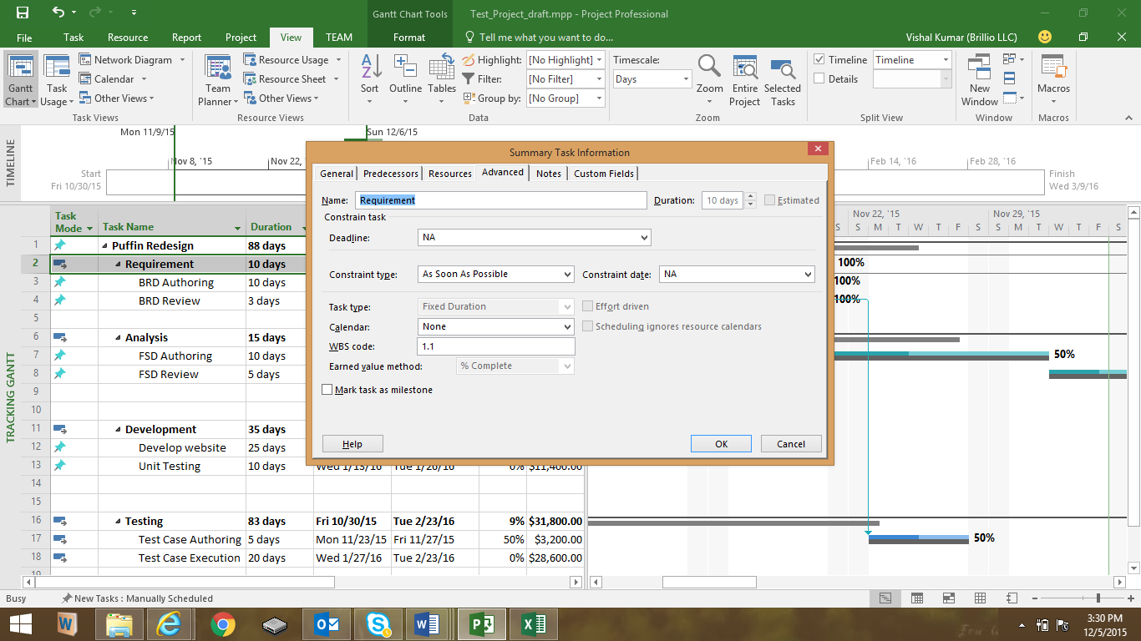

Go to “Advanced” option-> check the check box of “Mark Task as Milestone” at bottom left of dialog box and click on “OK”. It will mark Requirement Phase as a Milestone.

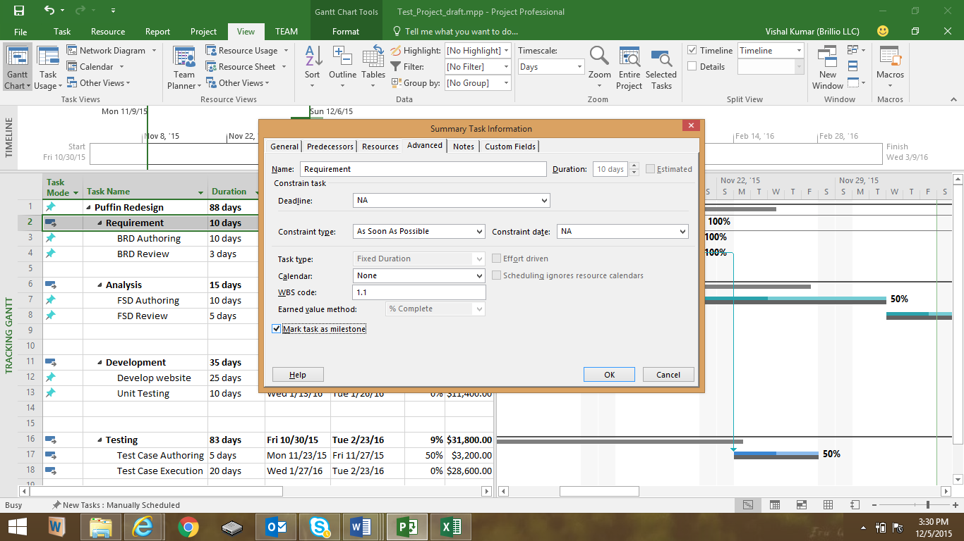

1. **Demonstrate a custom report to show resource usage (optional)**

To generate the Resource usage report, go to Report Tab-> Click on “Resource” and select “Resource Overview”.

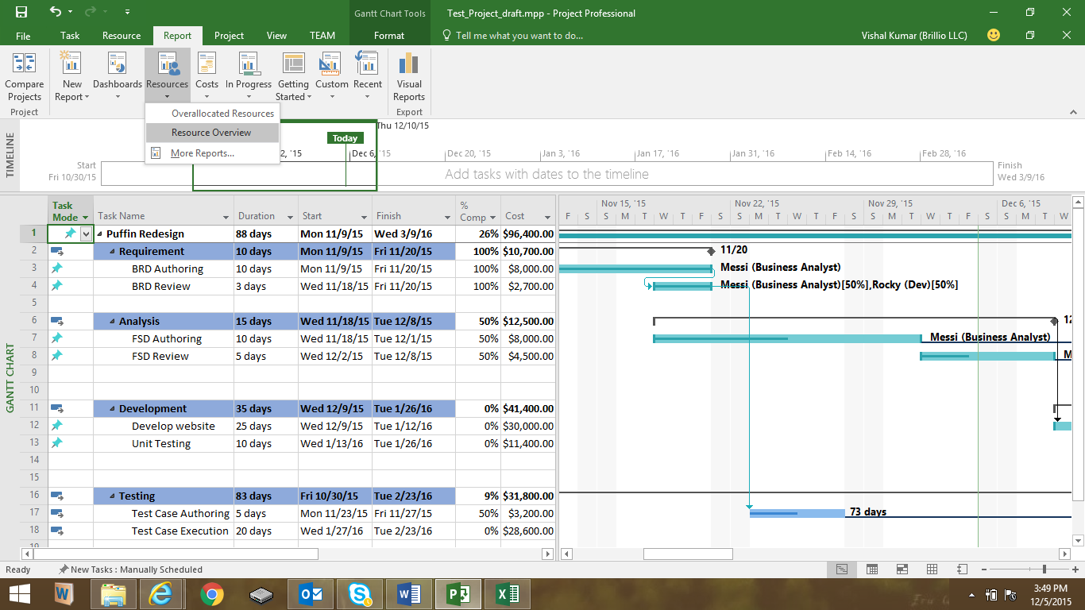

Above step will generate the below Resource Overview report.

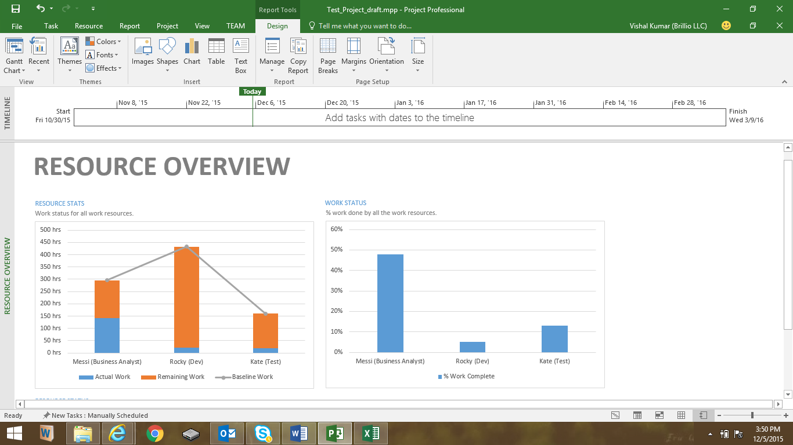

The other way to track the resource usage report is to, Go to “View” Tab-> Click on “Resource Usage”. This will give you an overview of usage of all the resources.

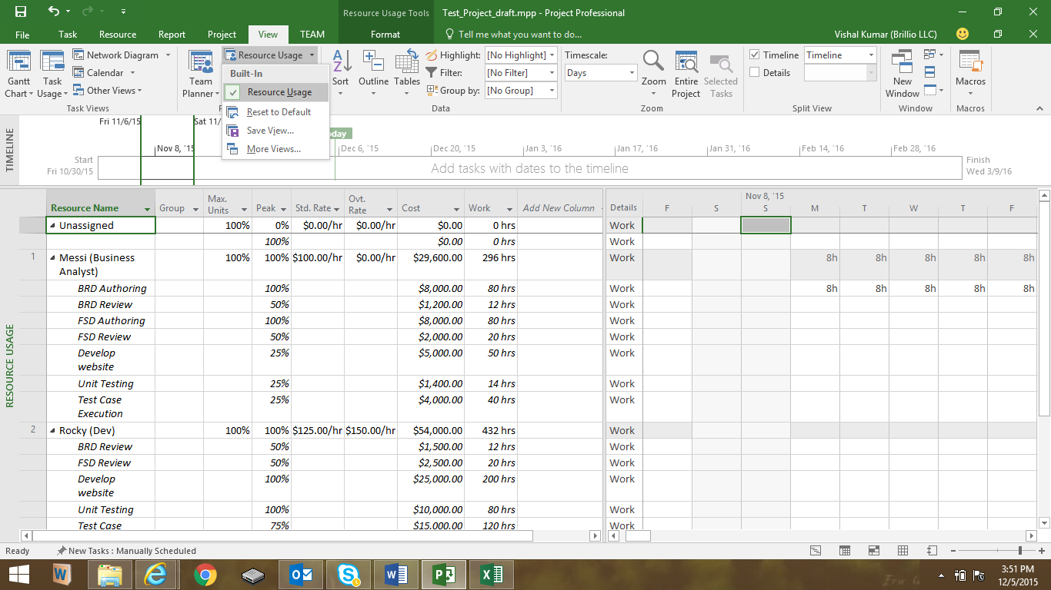

1. **Timeline to copy into a presentation**

Right Click on “Timeline” section of MS Project and select “Insert Task-> Existing Task

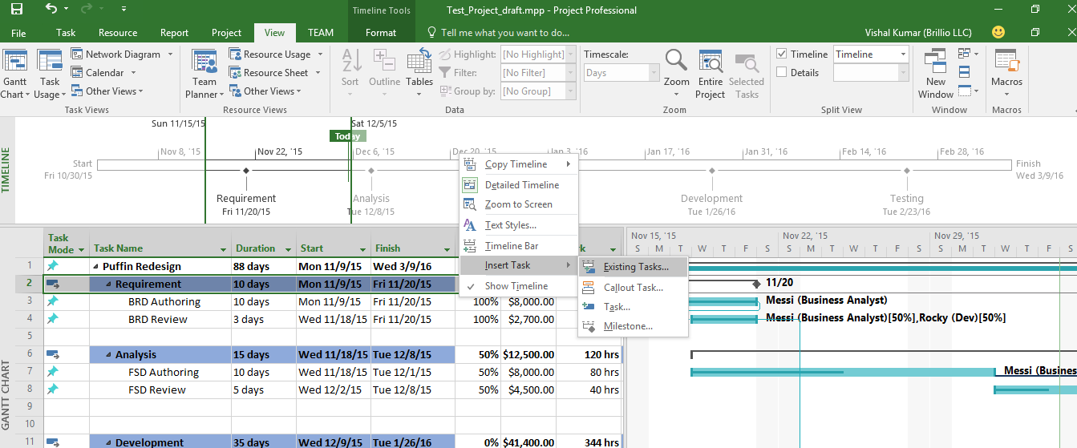

Then select the check boxes which you want to add and click on “OK”

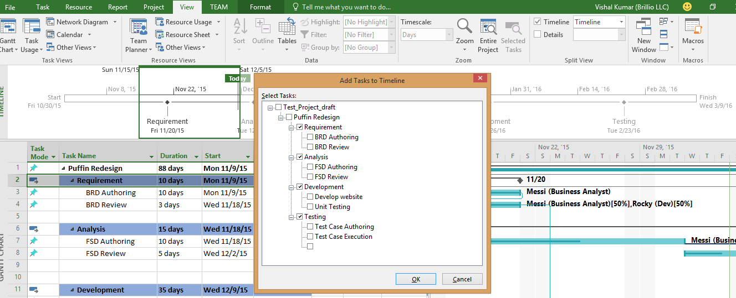

Again Right click on “Timeline” section and select “Copy Timeline”-> Then select “For Presentation”. Open the MS power point slide and simply copy it.

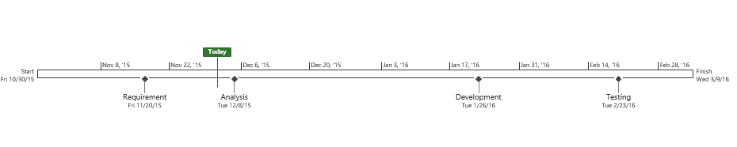

1. **Calculate Budget**

Go to “View”-> Go to Tables-> More Tables and select “Cost”

